Why Not Just Teach
the Traditional U.S. Algorithm?

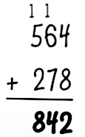

An algorithm is defined by a step-by-step procedure that works perfectly every time we apply it to computation. Also known as “stacking”, “borrowing” or “regrouping”, the traditional U.S. algorithm used for addition and subtraction is powerful, elegant, efficient, and yet simple. It requires little understanding of math beyond single-digit calculations and an ability to memorize a set of procedures. Historically known as “shopkeeper math”, the U.S. algorithm was used widely by early merchants who did not need any depth of mathematical understanding. So why not just teach the traditional U.S. algorithm?

The compact U.S. algorithm lacks transparency and obscures student understanding. The shorthand notations apply single-digit computation (to avoid negative numbers), and the procedure can be carried out without any knowledge of place value. The result poses a barrier to students’ emerging grasp of the base-ten number system and the underlying properties of addition and subtraction.

Memorized procedures send the wrong message to young mathematicians, who will become the future’s next innovators and problem solvers. We want them to have a deeper understanding of mathematics as part of a toolkit for solving problems that require creativity and flexibility.

Children tend to abandon their own efforts to make sense of mathematics when they are shown a systematic procedure, and in the process, lose the opportunity to compute flexibly and comprehend the strategies of others. The significant work of Kamii et al. (1993) found that rote learning of traditional algorithms can actually interfere with a child’s development of number sense.

All that said, we do value and teach the U.S. traditional algorithm. Prior to unpacking the algorithm, students engage in developing their own strategies for multi-digit computation that make sense to them. They can look at a problem as a whole, analyze the relationships of the numbers, and decide on an approach. Through this process, they expand their knowledge of place value, and how the operations of addition and subtraction “behave”, or specifically, their underlying properties. They also see themselves as unique learners who can solve problems flexibly using a variety of strategies.

Second graders’ strategies for solving 26 + 23
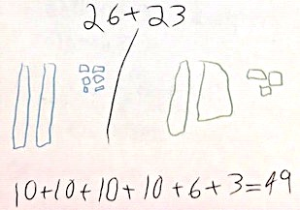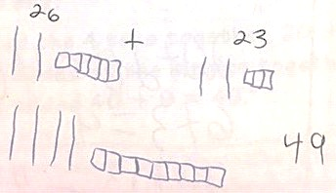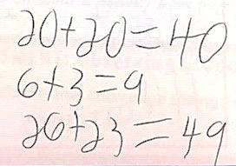

Third graders’ strategies for solving 248 + 172
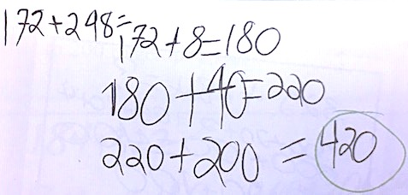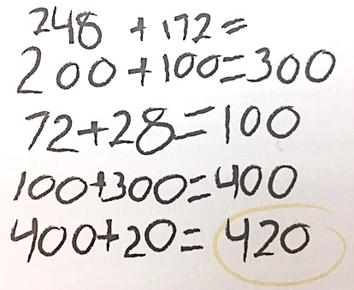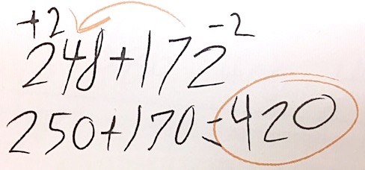

Fourth graders’ strategies for solving 2,597 + 728
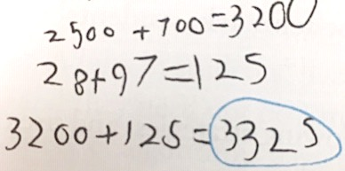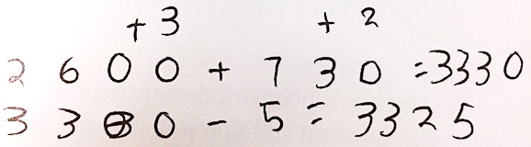

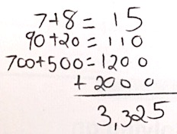

After students have had extensive experience developing and sharing their own strategies, they examine the traditional algorithm. By this time, they have attained powerful number sense and they enjoy the challenge of taking apart the U.S. algorithm to understand why it works. Thomas P. Carpenter’s (et al, 1997) landmark research supports this. He found that “Students who used invented strategies before they learned standard algorithms demonstrated better knowledge of base-ten number concepts and were more successful in extending their knowledge to new situations than were students who initially learned standard algorithms” (pg. 3). This view is also supported by the TERC Investigations curriculum (funded by the National Science Foundation), and the National Council of Teachers of Mathematics.

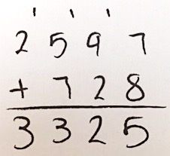

Teachers at LREI encourage students to approach problems in ways that they can understand. It takes a commitment from teachers to engage students in this type of authentic mathematical thinking. As students struggle to make sense of problems and develop their own strategies, they gain confidence in themselves as capable mathematicians.

Carpenter, Thomas P.; Franke, Megan L.; Jacobs, Victoria R.; Fennema, Elizabeth; Empson, Susan B. (Jan 1998). A Longitudinal Study of Invention and Understanding in Children's Multidigit Addition and Subtraction.
Journal for Research in Mathematics Education, v29 n1 p3-20 Jan 1998

Kamii, C., & Dominick, A. (1998). The harmful effects of algorithms in grades 1-4. In L. J. Morrow & M. J. Kenney (Eds.), The teaching and learning of algorithms in school mathematics: 1998 NCTM yearbook (pp. 130-140). Reston, VA: National Council of Teachers of Mathematics.

